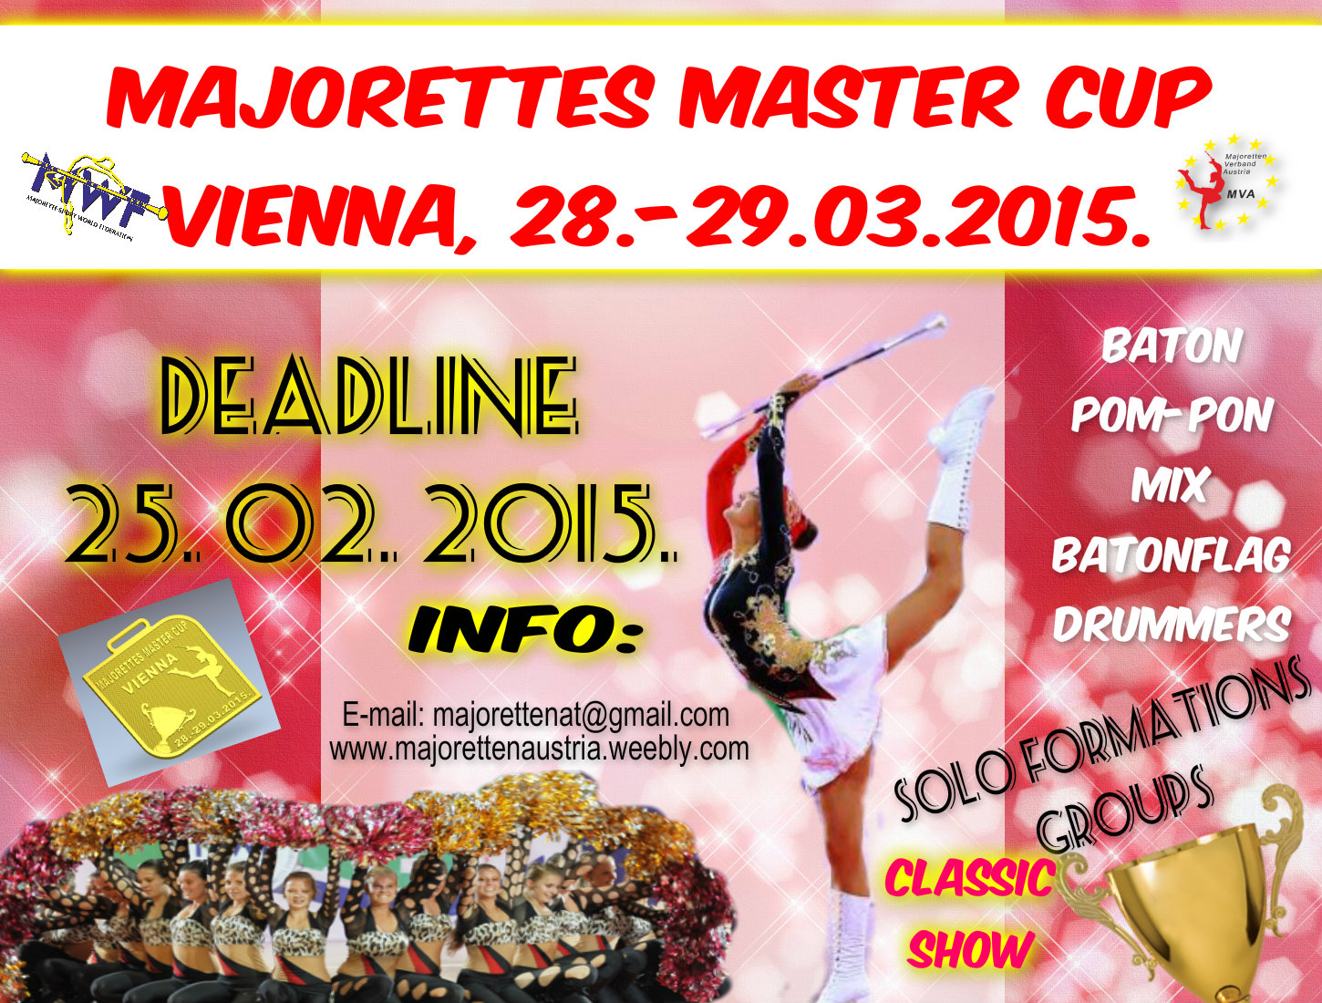

ORGANIZER: | MAJORETTEN VERBAND AUSTRIA  AUSTRIAN ASSOCIATION OF MAJORETTES /MVA/
TIME: | 28.-29. 03. 2015.
VENUE: | SPORT HALL
TYPE OF COMPETITION: | Open international championship in which they can compete all teams regardless of where the association member
REGISTRATION: | 20,00 EUR - each competitor –MAXIMUM 5 category  /for example: solo, mini f, mini mix, mini pom-pon, or group baton/
APPLICATION  DEADLINE: | 25. 02. 2015.
CONTACT INFO: | E-mail: majorettenat@gmail.com
WEB: | www.majorettenaustria.weebly.com
REGISTRATION FEE: | MAJORETTEN VERBAND AUSTRIA  Bank account:  MAJORETTEN VERBAND AUSTRIA IBAN: AT50 3200 0000 1204 3188  RBA-Raiffeisen bank Austria d.d.  DEADLINE FOR REGISTRATION FEE: 01. 03. 2015.

SATURDAY, 28. 03. 2015.
- 10,00-12,00-registration
- 12,00-SOLO FORMATIONS BATON / POM-PON/ MIX /BATONFLAG
- 19,00 –AWARD CEREMONY SOLO FORMATIONS -medals, cups , diploms
SUNDAY, 29. 03. 2015.
- GROUPS:
- 10,00-MIX / POM-PON /BATON/ SHOW/ CLASSIC/ DRUMMERS
- 17,00- AWARD CEREMONY-GROUPS -medals, cups, diploms - ________________________________________________________________________
Detailed schedule after DEADLINE-25. 02. 2015.
________________________________________________________________________________
AWARDS:
- medals, cup, diploms
INFORMATIONS:
- E-mail: majorettenat@gmail.com
www.majorettenaustria.weebly.com

